1. **ARMSTRONG**

**import java.util.Scanner;**

**class Armstrong {**

**public static void main(String[] args) {**

**int a[]=new int[20];**

**System.out.println("Enter a number : ");**

**Scanner sc=new Scanner(System.in);**

**int num=sc.nextInt();**

**int rem,d=0,copy;**

**copy=num;**

**while(num!=0)**

**{**

**rem=num%10;**

**d=d+(rem*rem*rem);**

**num=num/10;**

**}**

**System.out.print("The given number is : ");**

**if(copy==d)**

**{**

**System.out.print(" Armstrong ! ");**

**}**

**else**

**{**

**System.out.print("Not a Armstrong ! ");**

**}**

**}**

**}**

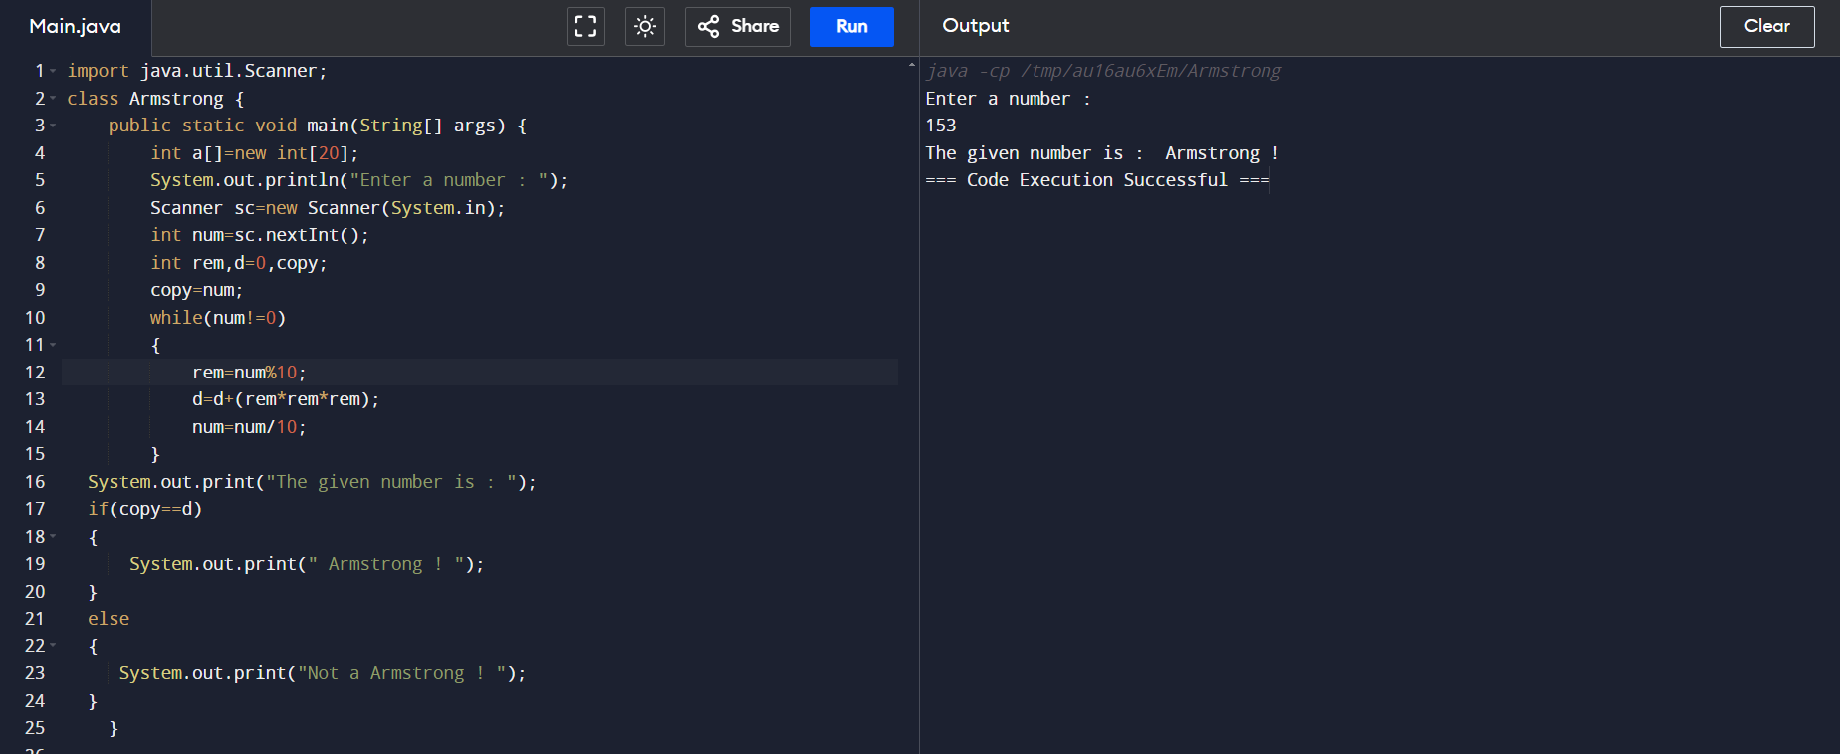

1. **Reverse a number**

**import java.util.Scanner;**

**class Reverse{**

**public static void main(String[] args) {**

**System.out.println("Enter a number : ");**

**Scanner sc = new Scanner(System.in);**

**int num = sc.nextInt();**

**int r = 0;**

**while (num != 0) {**

**int d = num % 10;**

**r= r*10+ d;**

**num = num / 10;**

**}**

**System.out.println("Reversed number: " + r);**

**}**

**}**

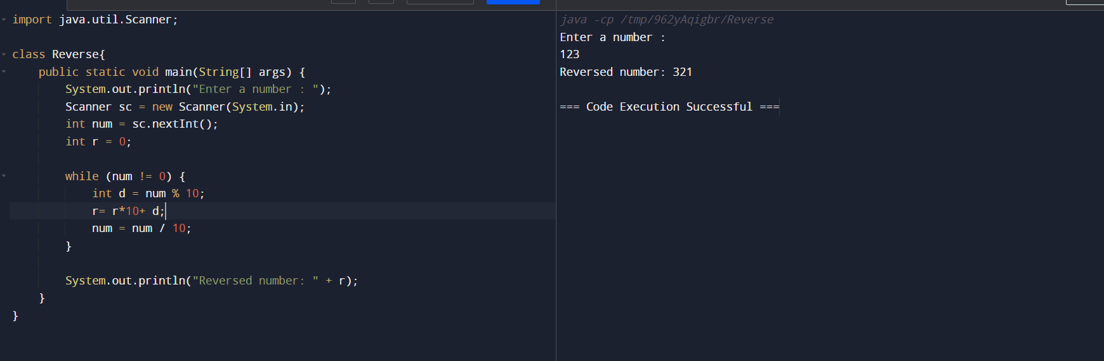

**3.CIPHER TO PLAIN**

**import java.util.Scanner;**

**class changer {**

**public static void main(String[] args) {**

**int a[]=new int[20];**

**System.out.println("Enter a number : ");**

**Scanner sc=new Scanner(System.in);**

**int num=sc.nextInt();**

**int rem,d=0,copy;**

**copy=num;**

**System.out.println("Enter a key : ");**

**int key=sc.nextInt();**

**int i=0;**

**while(num!=0)**

**{**

**rem=num%10;**

**d=rem+key;**

**a[i]=d;**

**i++;**

**num=num/10;**

**}**

**System.out.println("plain number : "+copy);**

**System.out.print("cipher number : ");**

**for(i=1;i>=0;i--)**

**{**

**System.out.print(a[i]);**

**}**

**System.out.print("\nplain number(reciver side) : ");**

**for(i=1;i>=0;i--)**

**{**

**System.out.print(a[i]-key);**

**}**

**}**

**}**

